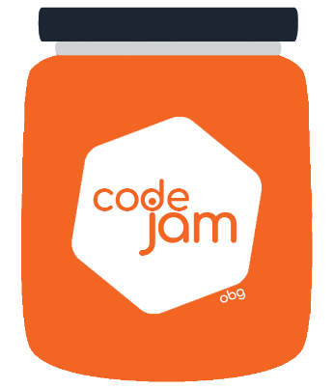

Challenge final 1: Find bones

Your dog used webpage to hide his bones coordinates where he buried his bone supplies.

But because he is just a dog he made it very miserably so now he needs your help to find them. Only thing he remembers is that he put keyword “bone” somewhere near.

Write as much as possible selectors to select all possible elements containing bone coordinates and parse data and store them in prepared array as {x: number, y:number}

What you need to do:

1. The time to complete is **30min**
2. Each team member has 10min to code.
3. The rest of the team can assist without coding (helping, giving ideas).
4. You are allowed to add code only in prepared area in index.html
5. More bones you find more points you get.